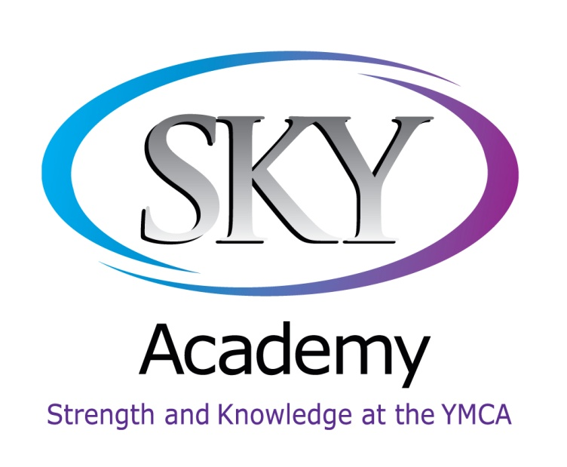
Honor Code
We believe that a safe and orderly school is of primary importance. When children behave in a respectful,
responsible, and safe manner, they learn more and develop into responsible adults whose “character counts.”
SKY Academy Honor Code expects students to be honest, kind, respectful, patient, proud, and courteous.

SKY Academy Honor Code is a school-wide plan that clearly outlines expectations. Proper behavior is recognized and consequences are given for breaking the code. As a County Public Charter School, SKY Academy uses the Code of Student Conduct published and distributed by the Sarasota County Public Schools. In order to ensure a safe and orderly learning environment, SKY Academy is enforcing stricter standards for its students.

Each parent must take an active role in supporting the plan. We want our children to learn to be responsible citizens. It is in the children’s best interest that parents and staff work together to ensure a happy, safe and productive learning experience.

Satisfactory Academic Progress: Students need to have a minimum Grade Point Average (GPA) of 2.0 to graduate from high school in the state of Florida. SKY Academy, as part of our Honor Code, will enforce stricter rules. Any student failing to achieve this minimum requirement at the end of any nine week period will be placed on Academic Probation and the parents will be required to attend an Academic Improvement Plan (AIP) conference. Parents are responsible for the implementation of all aspects of the plan. If there is proof on non-compliance with the requirements of the AIP, it will be considered a breach of contract between SKY Academy and the parents. The minimum requirement for participation in sports and activities at SKY Academy is 2.5.

The Honor Code at SKY Academy provides for a strong bond of trust among all members of the school community. The Honor Code instills in all students a mutual respect and understanding for the ideal of honorable behavior. Honor is a complex and multidimensional principle—moral aspiration that defies simple characterizations (UVA, Honor System, 2010.). The Honor Code at SKY Academy is a system that defines that students must refrain from lying, cheating and stealing or face severe sanctions by the School and Honor Committee.

The Honor Committee has two basic purposes: first, to increase the students’ understanding and awareness of the Honor Code: second, to preserve the integrity of the Honor Code by giving impartial and fair hearings to students suspected of committing an Honor Code violation. The Honor Committee will be made up of two faculty and three students. The faculty is appointed to the Honor Committee by the Administrative Team and will serve on rotating basis.

Lying is defined as any action, appearance, or statement, which an individual knows, or should know, to be untrue, given with intention to deceive. Examples of lying include, but are not limited to: making a false statement in an attempt to gain an unfair advantage; giving false excuses and explanations for being absent or tardy; bending the truth or pretending not to understand information that one is expected to know; lying by omission – leaving out pertinent information in order to gain an unfair advantage or to protect others; receiving permission from a teacher to go one place and going someplace else, forgery.

Stealing is defined as the taking or attempting to take property, whether physical or intellectual, without right or permission. Examples of stealing include, but are not limited to: taking something without permission of the owner even if the intention is to return whatever is taken; borrowing something without permission even if the intention is to return whatever is borrowed; finding something and making little or no effort to locate the rightful owner; unauthorized removal of academic materials from a teacher.

Cheating is defined as using or attempting to use unauthorized assistance or advantage in academic work that is submitted as one’s own individual efforts or the giving of such assistance to others. Examples of cheating include, but are not limited to: turning in work that was not entirely done by the student and giving the impression that the work was done by the student; copying homework without the consent or approval of the teacher; using translation sited off the internet or software in foreign language classes; using workbooks from a previous year with answers already written in; working with others on any assignment which is intended to be an independent effort; dividing up work among group members that was intended to be done together; using a similar assignment from a past class (book report, essay, etc.); allowing one’s academic work to be used in place of another’s; having notes or textbooks visible during tests or quizzes; giving or receiving information about a test, quiz, or other assignment prior to starting the assignment; this includes receiving from someone unauthorized specific test questions or information about topics included in the assignment; glancing at someone else’s test or quiz; using a calculator when instructed not to use it; not telling your teacher that the score on your test is added wrong; not telling your teacher when a wrong answer was not marked wrong; instead of reading the original book or original literary work, reading a condensed version, seeing the film or video, or using Cliff’s notes; reading an English version of a work assigned in a foreign language.

Plagiarism is defined as literary theft, misrepresentation, and falsification. Explanations of plagiarism include, but are not limited to: stealing someone’s ideas or thoughts or borrowing dishonestly from another; signing one’s name to a daily assignment or major work to declare that work totally one’s own; not clearly marking the source of the information, thoughts or ideas; inadvertent documentation mistakes that allow another’s words, thoughts, or ideas to be credited as one’s own due to improper referencing. Plagiarism is prevented when the proper form of documentation is followed.

A severe clause can be enacted automatically when the student performs one of the violations listed below: Sever Clause Violations – Fighting, Drugs, Weapons, Profanity, Defiance of School Personnel, Assault upon a Staff Member, Continuous Disruptive Behavior. The Parent/Guardian will be called to pick up the students. Any infraction within the Severe Clause will result in immediate Out-Of-School (OSS) Suspension and possible withdrawal from SKY Academy.

